Webform: View or request copies of planning documents

Tracker ID: 49

Choose to request hard copies of documents

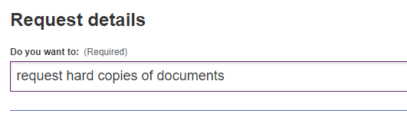

Add two request lines

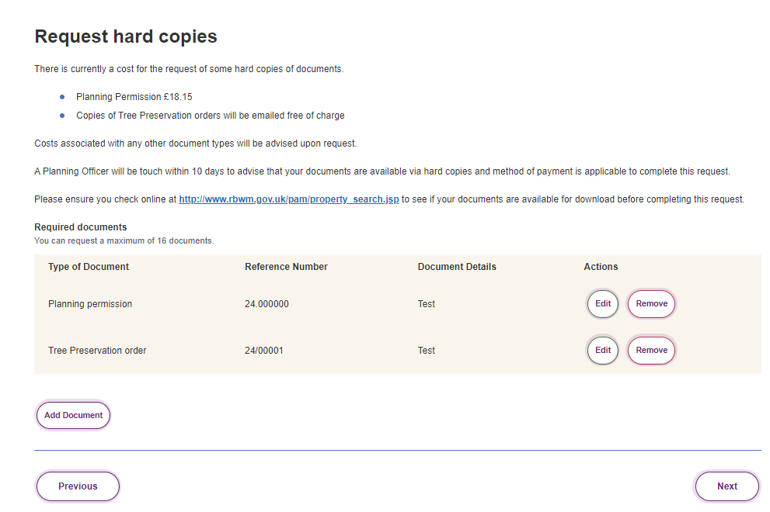

Once click “Next”, an error message is show as below.

